UML

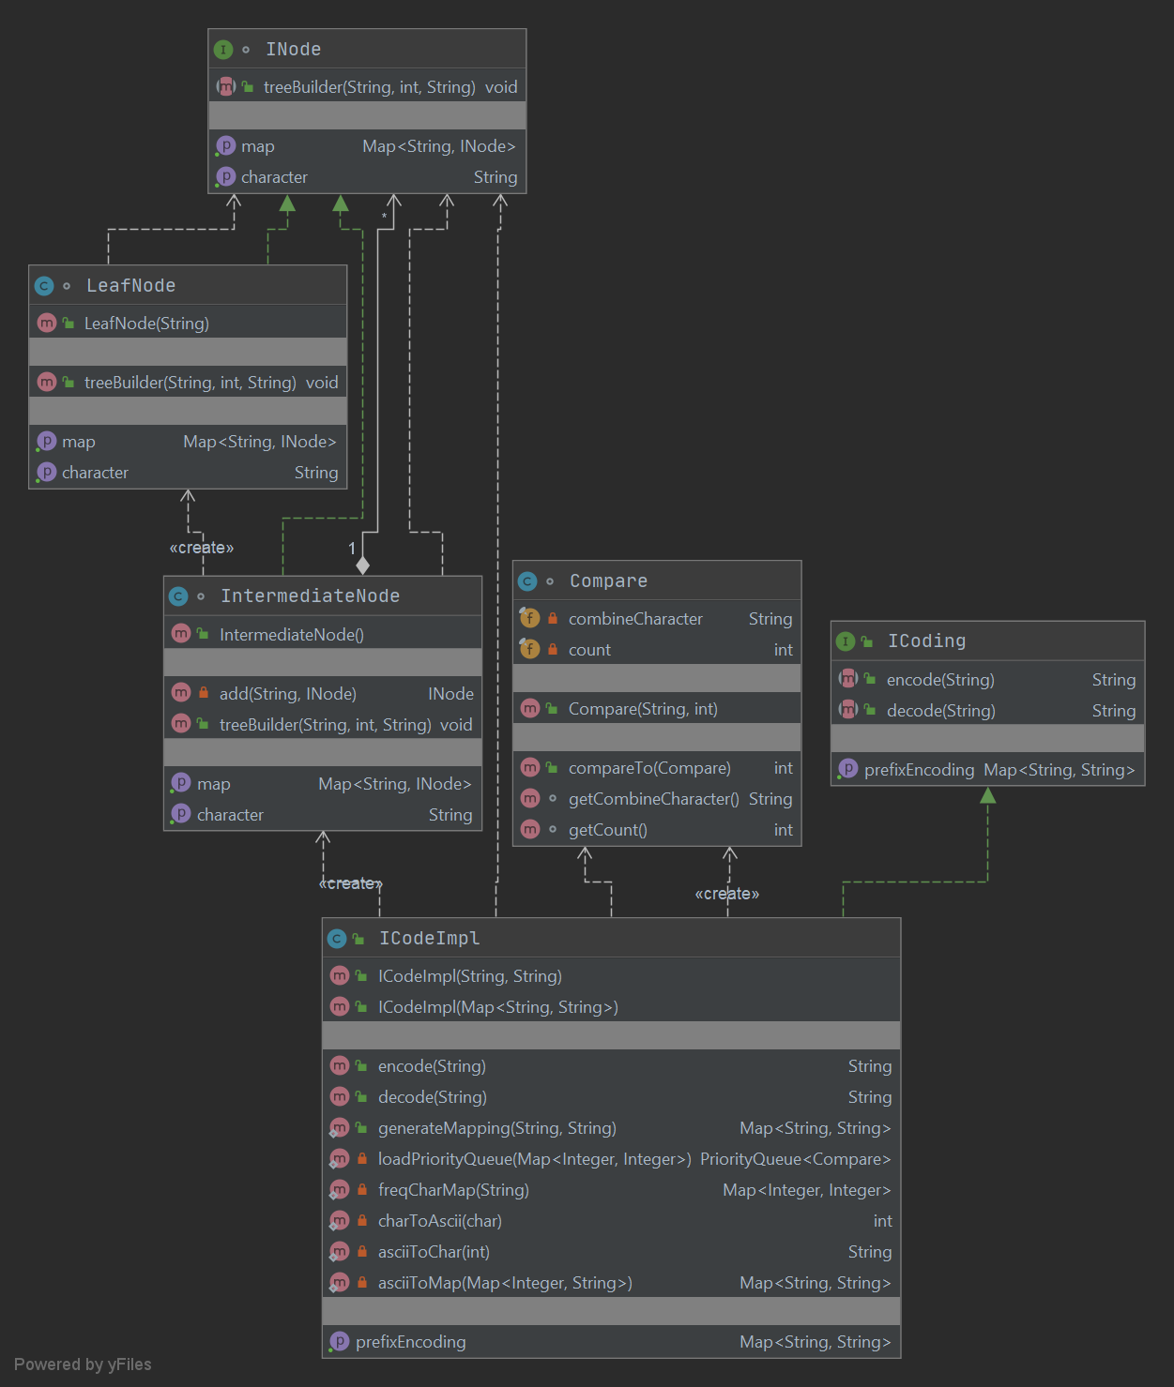

Test Plan

The test plan has all the checks at a high level and would be improved during course of development of the homework. Certain assumptions have been made while designing the problem. If no encoding scheme is given for building the map, it is not taken as binary encoding by default and an exception is thrown. When the user enters the prefix encoding the map is assumed to be of valid type and no checking is done to make sure of the validity. Also, the map when entered by the user must be entered in a specific format. An example is as follows, {a=10, b=100, c=01, d=010}. Testing has been done to elaborately taking into consideration all the edge cases while encoding and decoding is being performed.

